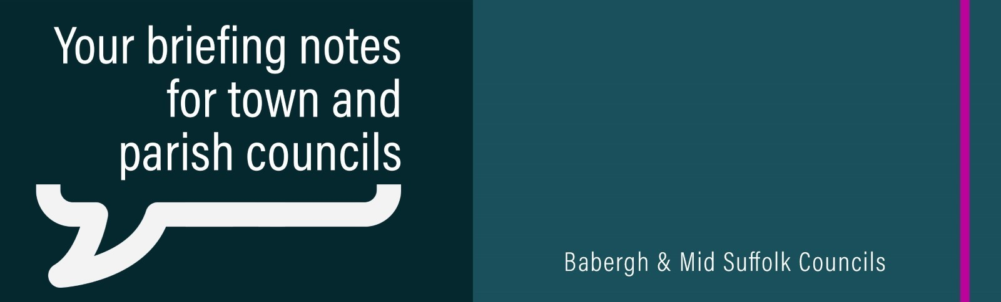

Communities invited to ‘fun days’ across the districts
Community Fun Days are coming to Babergh and Mid Suffolk this summer, giving people the opportunity to come together and have fun during the school holidays.
Babergh events (from 10am to 2pm):
- Friday, 2nd August at Stevenson Centre, Stevenson Approach, Great Cornard, Sudbury, CO10 0WD
- Monday, 5th August at Holbrook Village Hall, The Street, Holbrook, Ipswich, IP9 2PZ
- Friday, 9th August at Hadleigh Pool and Leisure, Stonehouse Road, Hadleigh, Ipswich IP7 5BH
UK Parliamentary General Election
On Thursday, 4 July, hundreds of Babergh and Mid Suffolk staff helped make democracy happen by manning polling stations, counting ballot papers overnight and everything in between. The results for the three constituencies counted by the councils are now available on the councils’ websites.
Changes to Babergh cabinet
Following her election as Babergh's leader last month, Cllr Deborah Saw has announced cabinet changes - with new portfolios created to help deliver the administration’s action plan.
Babergh District Council Cabinet as of June 2024:
People and Place – Cllr Deborah Saw (Leader)
Finances, Assets and Investment – Cllr John Ward (Deputy Leader)
Cabinet Member Without Portfolio – Cllr Dave Busby (Deputy Leader)
Performance and Resilience – Cllr Alastair McCraw
Thriving Communities – Cllr Daniel Potter
Sustainable Economy – Cllr Derek Davis
Housing – Cllr Jessie Carter (shadow Cllr Ruth Hendry)
Heritage, Planning and Infrastructure – Cllr Sallie Davies
Climate Change, Nature Recovery and Biodiversity – Cllr Helen Davies

